# Launching an EC2 instance with web server.

Log into your AWS management console, search for EC2 and click on it.

You should see something as below.

Click on Instances(running) section and it will show you the below screen.

Click on Launch instances button here and provide a name to your instance.

To generate a key pair for this EC2 instance click on Create a new key pair button.

Give a name to your key-pair and choose RSA as the key-pair type, for now we will choose. ppk as the key-pair file format. After you’re done choosing the details click on the create key-pair button.

Expand the advanced details section and go to the user data field.

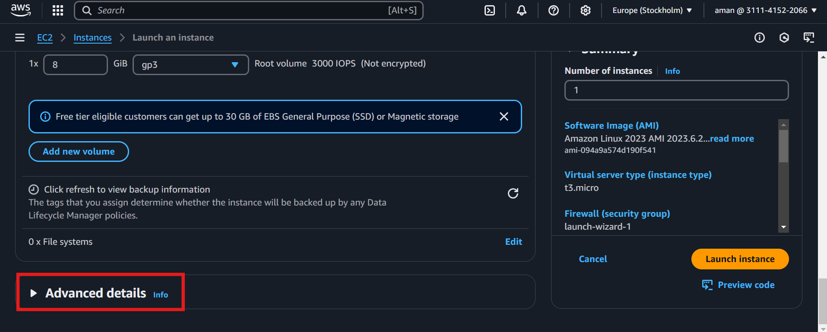

Paste the following code into the user data field --->

***#!/bin/bash***

***yum update -y***

***yum install -y httpd***

***systemctl start httpd***

***systemctl enable httpd***

***echo "<h1>Hello World from $(hostname -f)</h1>" > /var/www/html/index.html***

Click on launch instance and come back to the instances screen. You should see the below instance created and running.

Copy the Public IPv4 address of your EC2 instance and then paste it in your preferred browser with ***http.//*** as prefix. You should be able to see the below webpage confirming that you have successfully configured a web server on your EC2 instance. Cheers!!!

# Several ways to connect to OS level of the EC2 instance.

## SSH into EC2 instance.

Download a Putty client through ***putty.org*** website.

After clicking download putty download any of the installers and install it.

Grab the public IPv4 address of your EC2 instance.

Ec2-user is the default user created for an EC2 instance. Paste the IP address as shown below (ec2-user@<IP address>) in the destination field. You can also save this instance by providing a session name and hitting save.

Expand SSH section and then expand Auth section, browse and place the .ppk file generated and click open.

Et voila!!!! You are in the OS level of your EC2 instance. Pat yourself on the back.

# Other ways to access EC2.

Select your EC2 instance and click on Connect button.

In the EC2 Instance Connect section click on connect.

Aren’t you proud of yourself. You’ve learnt another way to connect to your EC2.

In the connect to instance section click on EC2 serial console and click connect.

Note: If you run into any access issue, click on manage access and select allow. That should get you to the connect button.

You’re on a roll. You’ve learnt another way to get access to your EC2 instance.

